Healthwatch City of London
Nutrition and Catering
Enter and View Visits
to
St Bartholomew’s Hospital

City of London

January 2017

Healthwatch City of London
6th Floor, Tavis House
1-6 Tavistock Square
London WC1H 9NA
Contents

Purpose of this report 5
Recommendations 6
Food for health 6
Staff 6
Menu provision 7
Increase food choice and variety 7
Food service 9
Reduce wastage and ensure patients eat 9
Related to the cystic fibrosis ward 9
Spread good practice 10
Gather regular feedback 10
Ward specific recommendations 10
Medical oncology 5A and 5B 10
Haematology oncology 5C and 5D 10
Cardiac 3A 11
Cystic fibrosis and respiratory 4D and E 11
Introduction 12
Background 12
Aims and objectives 13
Methodology 13
Limitations 14
FINDINGS 15
General 15
Outcomes of ward visits 16
Ward 5A (medical oncology) 16
Staff oversight 16
Ward set-up and service preparation 16
Variety and choice of food 16
Food service 18
Ward 5B (medical oncology) 19
Staff oversight 19
Kitchen 20
Ward set-up and service preparation 20
Variety and choice of food 21
Food service 21
Additional comments 22
Ward-specific recommendations for medical oncology 5A and 5B 23
Ward 5C and D (haematology oncology) 24
Ward set-up and service preparation 24
Variety and choice of food 24
Food service 25
Additional Comments 25
Ward-specific recommendations 25
Ward 3A (cardiac) 26
Staff oversight 26
Ward set-up and service preparation 26
Variety and choice of food 27
Ward specific recommendations 28
Ward 4D and E (cystic fibrosis and respiratory) 29
Note 29
Staff oversight 29
Facilities 29
Ward set-up and service preparation 30
Variety and choice of food 30
Additional comments 31
Ward specific recommendations 32
Update 32
Staff concerns 32
Next steps 33
Acknowledgments 34

Purpose of this report
This report details observations on catering and nutrition provision and provides suggestions for improvement, following an Enter and View visit at St Bartholomew’s Hospital. Findings will be used to inform the incoming catering contractor and to ensure they meet the required CQC standards with regards to quality of care. This report should be read in conjunction with the Recommendations listed below. Additional ward-specific recommendations are included in the relevant sections of this report.

Recommendations
The following list of recommendations is put forward for consideration, based on findings from observations of meal services and discussion with staff and patients. Ward specific recommendations are also reproduced within this section.
It should be noted that feedback on the quality of care and the attitudes of ward staff was overwhelmingly positive. These catering and nutrition recommendations are proposed to support this.

Food for health
- There appeared to be limited healthy food choices available in many of the wards. There were repeated requests from patients to introduce a much wider range of ‘healthy choice’ foods, including salads. This is likely to support health recovery and wellbeing, and is a key recommendation of this report.
- Some of the food provided was not necessarily beneficial for recovery. Provision of additional salt and high fat foods (e.g. tiramisu) on the cardiac wards, for example, risks undermining expert dietician advice. It is recommended that expert dietetic advice is regularly sought to review the nutritional content of the food, particularly on the cardiac ward, to ensure it is actively promoting health and recovery and is in line with the guidelines on diet issued to patients.
- It is likely that the food patients receive, with the nutritional modifications to promote better health (e.g. less sugar, less salt, or in the cystic fibrosis or oncology wards, potentially with greater calorific loading) will taste different to those they may be used to. It is recommended that literature is provided in all the wards and as part of the nutrition/dietician discussions to explain this and to emphasize the benefits of – and the reasons for - the revised diets.
- It is recommended that literature on how food can affect a person’s condition and the sorts of foods patients should be eating/avoiding are posted around the wards. E.g. during chemotherapy, for patients with heart disease or cystic fibrosis etc. This is likely to support patient adherence to the diets provided.

Staff
- MUST training was described as very successful. However, not all wards had a Nutritional Link Nurse and knowledge of the impact of diet on health was variable. It is recommended that all wards appoint and appropriately train a post holder as soon as possible, with allocated (protected) time to undertake the required training and clear information posted in each ward and staff area as to who this is. Similarly it is recommended that all ward staff are given protected time to improve their knowledge about nutrition and to attend training/workshops if applicable.
- Staff on at least one ward did not appear to have received training on allergies and it is recommended that information is posted in all of the regen kitchens which outlines the hospital policy on this.
- There was inconsistency with regard to whether staff wore a hat and gloves when serving food. It is recommended that staff are told of the hospital guidelines on this.
- It is recommended that the new catering provider offers refresher training for current staff on the operation of the food trolleys, to ensure that food can be kept hot (and appealing to patients) during the food services.
- There was considerable uncertainty amongst the catering staff about job security and potentially new Terms and Conditions. It is recommended that staff are given detailed information about the new contractors, job security and likely employment conditions, as soon as possible.

Menu provision
- A lack of menus in all of the wards visited meant that nursing staff were reading options to patients aloud, and then recording their choices ad hoc. This resulted in patients not receiving food they had ordered and consequently led to people not eating their meals and food wastage. Similarly, it is likely to have taken considerable nursing time to explain and note all the options. It is recommended that menus are provided to all patients at their bedside and that there is a systematic way of recording choices. An electronic system which could be transmitted directly to the kitchen would be ideal, but a simple paper chart would also be sufficient.
- Some patients (and staff) were unfamiliar with food items on the (read-out) menus. It is recommended that the menus include pictures and descriptions of the different foods and clearly states whether they are suitable for certain diets (e.g. labelled as vegetarian, halal, kosher etc). This is also likely to be beneficial for patients who have limited English.
- Food wastage was a problem on a number of wards. Menus patients could read ahead of time with pictures and clear labelling to ensure that people know what they ordering and are not surprised by what arrives, would reduce this.
- Staff turnover and agency staff use was high on some of the wards. It is recommended that clear information on what food is available for patients, when and where it is kept is posted in staff areas.

Increase food choice and variety
- There appeared to be very limited option for people who chose to not eat certain foods e.g. for religious reasons. There is an urgent need to expand culturally appropriate menus and to also offer a wider range of vegetarian food, which could be provided in many circumstances if particular meat based products were not suitable.
- Some patients, particularly on the cystic fibrosis ward, were buying takeaways rather than eating the food provided from the hospital. This meant that the dietician was often not aware of what had been eaten and meant some patients were spending significant amounts of money on high fat, high salt and sugar takeaways. This also happened on wards where weight maintenance or gain was not necessarily recommended. It is suggested that an improvement in the quality and appeal of hospital food would encourage less reliance on external catering and that a full discussion with patients takes place as to their types of likes and dislikes with flexibility to provide specific menus for groups of patients.
- It appeared that the range of sandwiches offered to patients on the wards was extremely limited. However a larger number of sandwich options are provided in the hospital restaurants and day unit. It is recommended that the restaurant and patient catering teams communicate to ensure that the full range is also available to patients on the ward. This should include vegetarian options.
- Toast and other plain food was requested by a large number of patients, particularly those who were undergoing procedures where they felt nauseous, and could not eat a full meal. It is recommended that toaster provision is reviewed to investigate whether it is possible to purchase models which comply with fire safety guidance and hospital regulations. A toaster is already provided in the cystic fibrosis ward, for example.
- All of the patients were observed to have jugs of water available at their bedside. Patients also indicated they would like the option to be able to make tea (including herbal tea) and coffee if possible.
- Food choices appeared to be very limited for those on a soft diet. It is recommended that the hospital investigates the possibility of providing blenders in each of the ward kitchens to enable staff to make smoothies from blended vegetables and fruit, which would be healthy and nutritious.
- There was inconsistency across the wards related to whether people could have second helpings and snacks, and when food was available. It would be useful to have a list of snacks that are available in between meals and any restrictions on availability posted in the wards for patients to read, and also in the staff areas.
- There were found to be very few breakfast options available for patients – this was essentially a limited choice of cereals and untoasted bread. It is recommended that the breakfast menus are revised to expand the options available (e.g. to include fruit, yogurt etc.) and to increase the choice within these options.
- A monthly menu rotation would be welcomed, especially as many patients are isolated on the ward.

Food service
- It was apparent that staff did not necessarily document patient needs and preferences and that much of this information was ‘in people’s heads’. It is recommended that this information is formally written down to ensure that patients who need support to eat or have specific dietary requirements are not missed, if there is a change of staff.
- Currently food is ordered on the basis of bed number. This means that if a patient moves beds, the next occupant of their original bed gets the food chosen. It is recommended that the process for identifying and linking orders to patients is reviewed to ensure that their food choice ‘travels with them’, and is not simply given to a new patient occupying that bed.

Reduce wastage and ensure patients eat
- It appeared that the main kitchen changed the food sent to the ward meaning that patients did not receive what they ordered the day before. It is recommended that there is a daily check to ensure the food choices which appear on the menus are actually available in the kitchens.
- It is recommended that when a patient’s choice of food is not available, the patient is given the chance to choose another meal instead of ward staff simply making a choice on the patients’ behalf.
- There were a number of comments about the poor quality of the food and the cooking of it. While in the vast majority of cases it was felt that staff did the best they could with limited resources, this was a key factor in patients not eating the food provided. It is recommended that this is reviewed ahead of the new contract implementation.
- Some patients who felt unwell were put off eating by large portion sizes. One ward had successfully implemented a simple system of noting whether patients wanted a small or large helping. It is recommended this is rolled out to the other wards not currently doing this, to encourage people to eat.

Related to the cystic fibrosis ward
- Patients on the cystic fibrosis ward were given up to three vouchers to the value of £6.50 each to supplement their food intake from restaurants in the hospital. It is recommended that this policy is reviewed and the funds (up to £19.50 per day per patient) used to provide better quality food and a wider range of dietician approved foods. While it is recognized that patients with cystic fibrosis require extra calories, these calories are unmonitored by dieticians and the cost extremely high to the hospital.

Spread good practice
- It was notable that staff, wherever possible, supported initiatives to improve the catering and nutrition ‘experience’ for patients and were supporting a range of initiatives such as the Breakfast Club. However, these (often very valued) initiatives appeared to be limited to individual wards and there was no transfer of knowledge to other wards, or spread of good practice. It is recommended that information on the schemes, what works and what does not work and the cost implications is shared between wards, possibly through a newsletter or posters in staff areas.

Gather regular feedback
- It would be helpful to be able to give the kitchens feedback on the meals from staff and patients on a more regular basis, through the use of comment cards and drop boxes, for example.
- It is recommended that there is a formal system to collect and pass on feedback information. Potentially this could be through the inclusion of a question in the iWantGreatCare.org feedback form which currently does not include any questions on catering or nutrition, or a weekly bullet point email be sent to the kitchen identifying patient preferences.

Ward specific recommendations
The following recommendations are related to specific wards:

Medical oncology 5A and 5B
- To provide literature on the effects of chemotherapy and radiation therapy on appetite and taste.

Haematology oncology 5C and 5D
- Milk should be served separately to cereals.
- The croissants were served in a small pudding bowl with a knife, butter and jam. Serving them on a plate would make them easier to eat.
- The croissants are heated in an oven and should be kept in the heated trolley for distribution so they are warm when reaching the patient. The softer texture made them easier to eat.
- All patients should be offered the choice of croissants and the special menu when it is appropriate to their treatment.
- Trays could be replaced with something more likely to improve presentation of food – could this be through sponsorship by a retailer or tray manufacturer?

Cardiac 3A
- One patient commented that if they were asleep when staff came round to take their order then they simply chose for them, which led to people often not eating it when it arrived. It was recommended that patients were asked if they wanted to be woken up for food, and the bed ‘labelled’ as such.

Cystic fibrosis and respiratory 4D and E
- A menu that is more varied and appealing to younger cystic fibrosis patients should be introduced to avoid the need for patients to be spending large sums of money on takeaways and food externally. The prevalence of takeaways also risks undermining the expertise of the dieticians.
- All patients need to be informed of the extra snacks available and how to access food if they are undergoing treatment.
- It is recommended that toasters are made available to patients on both sides of the wards – at the moment only one of the kitchens has a toaster.
- Breakfast should be delayed to ensure it does not overlap with people washing/using the toilet and receiving medications.
- It is recommended that day staff serve breakfast, rather than night staff.
- See also recommendations above.

Introduction
Healthwatch City of London represent the views of people who use services, in the Square Mile, and ensures that their voice is heard by decision makers in all aspects of health and social care and wellbeing.
Local Healthwatch have powers of entry, and providers have a duty to allow entry, if local Healthwatch operate under the principles of the legislation set out below:
- To go into health and social care premises to hear and see how the consumer experiences the service.
- To collect the views of service users (patients and residents) at the point of service delivery.
- To collect the views of carers and relatives of service users.
- To observe the nature and quality of services.
- To collate evidence-based feedback.
- To report to providers, regulators, Local Authority and NHS commissioners and quality assurers, the public, Healthwatch England and any other relevant partners.
- To develop insights and recommendations across multiple visits to inform strategic decision making at local and national levels.

Background
Healthwatch City of London staff and volunteers took part in PLACE assessments at St Bartholomew’s Hospital, in the City, in 2016. Healthwatch Tower Hamlets also carried out Enter and View visits at the Royal London Hospital in February/March 2016 and observations were made on the catering and nutrition provision. The recommendation arising from the Tower Hamlets report, that there be a change of catering provider, has now been implemented and Serco catering is being rolled out across Bart’s sites, with St Bartholomew’s taking this up in 2017.
Other central recommendations included:
- The introduction of an a la carte meal service rather than a rotating menu.
- The introduction of a Breakfast Club (reviewed within the report), with a greater variety of breakfast items available.
The report also found that Malnutrition Universal Screening Tool (MUST) training appeared to have increased, and was more widespread amongst nursing staff than during a previous visit.
Subsequent to the outcomes of these assessments, Healthwatch City of London was approached by Rashmi Soni, Senior Dietician at Bart’s Health NHS Trust to carry out Enter and View visits at St Bartholomew’s Hospital. This was to coincide with the transition to the new catering provider, Serco.
Visits took place in December 2016 and were informed by the recommendations from Healthwatch Tower Hamlets, which carried out similar Enter and View visits at the Royal London Hospital in February/March 2016.

Aims and objectives
The overall aim of the Enter and View was to observe and gather feedback on catering and nutrition provision in order to inform St Bartholomew’s Trust management and relevant others, as above.
Specifically, the key objectives were:
- To observe the food service both prior to serving and during food service across the entire day. This included the newly initiated Breakfast Club, lunch and dinner, on different days.
- To speak to patients, visitor, carers, catering and ward staff in order to develop a greater understanding of their perspective on the food, food service and support offered. Also to ascertain what they would like from the new catering service.
- To observe ward practices (by speaking to patients, visitors and staff) on fulfilling Bart’s Health and national expectations around hydration and nutrition standards (e.g. Malnutrition Universal Screening Tool (MUST), Red Tray Policy etc).

Methodology
A total of eight Healthwatch City of London representatives took part in the visits including Healthwatch City of London staff and a Healthwatch Tower Hamlets staff member. The representatives attended training on catering and nutrition (provided by dieticians based at St Bartholomew’s), prior to the visit.
Visits were undertaken to the following wards at St Bartholomew’s:
- two medical oncology wards,
- two haematology oncology wards,
- one cardiac ward,
- one cystic fibrosis ward,
- one respiratory ward.
In all cases, visits were to observe catering and nutrition provision across the wards, and how particular needs related to individual health conditions, were being met. Visits took place throughout the day, covering lunch and dinner and the newly initiated Breakfast Club.
Wards were not informed of the visits ahead of time. Instead, a member of staff from the dietician team introduced Healthwatch City of London representatives to the ward manager on the day/time of the visit and provided some background to the procedures on each ward.
On each ward, patients, visitors, carers, catering and ward staff were asked to give their views on the nutrition provision and support.
Comments from staff, patients and visitors are combined to protect anonymity and to draw out the main themes.

Limitations
It should be noted that while this Enter and View was undertaken as fully as possible, there are some limitations to the scope of the review and the methodology which may influence the findings. These are below:
- Many patients went to sleep following the meal services and it was not always possible to get feedback from them. Consequently, views presented are from a proportion of patients only.
- Different staff had different levels of knowledge about usual practice on the ward – this is reflected within the report.
Whilst every care was taken to insure the information in this report is correct, it is accepted that there may be unintentional inaccuracies in this draft.

FINDINGS
Staff were helpful and welcoming and took time to talk to the representatives, in all of the wards visited. They were keen to provide information and welcomed the opportunity to input into the process.

General
The following feedback applied to all of the wards visited:
- Adequate hydration was a priority - all patients were provided with a jug of water and a glass, which were within their reach.
- Individual fridges were provided on most of the wards which were very much appreciated by patients.
- None of the patients, across the wards observed were provided with a menu for any meal service.
- Much of the knowledge about the particular catering and nutrition needs of patients appeared to be ‘in the staff’s heads’, rather than formally written down, meaning that if there were any staffing changes, patient needs/preferences were potentially missed.
However, there were a number of inconsistences in service and knowledge across the wards:
- The Nutritional Link Nurse role was a voluntary post and there was variation in the time allowed for training across different wards.
- There was inconsistent recording of food consumption for individual patients and it was unclear whose responsibility this was.
- While there were many innovative initiatives within wards to encourage people to eat, such as the Breakfast Club, the Come Dine with Me initiative for friends and family and the Ice Cream and Cake Tea, it did not appear there was any transfer of learning or roll out to different wards.

Outcomes of ward visits
In each case representatives visited the ward and spoke to patients, visitors and staff. They also observed the meal service. Key observations and feedback are listed in each case.

Ward 5A (medical oncology)
Meal service observed | Lunch, 11-2pm
Number of patients engaged | 7
Date of visit | 13/12/2016
The kindness of the staff was noted and appreciated by patients.
Appetites varied between patients, and in relation to their health. Overall, the patients interviewed felt the hospital managed this as best they could. Patients were able to get more food if they wanted it, although it was not always what they would prefer. Specific comments and observations included:

Staff oversight
- 5A does not have a Nutritional Link Nurse, the post holder had left the Trust a few months ago, and a replacement was being sought.
- The staff interviewed had been trained on MUST and were able to explain how this worked.

Ward set-up and service preparation
- There was a notice on the main door saying that this ward operated a ‘protected meal time’, with times.
- No patients were on ‘red tray’; however they were spare red trays on the food trolley.
- There was a notice behind one patient bed to say that this patient was ‘Nil by Mouth’. However this was not clearly visible.
- Staff spent very little time setting up patients’ tray tables prior to the lunch service or in ensuring that patients were in comfortable position to eat.
- Patients were not asked if they wanted to wash their hands prior to lunch service, but wipes were provided.

Variety and choice of food
- There were no menus near any of the patient bedsides. Representatives were informed that staff read out the menu items to patients the night before.
- The paper ordering system did not always take account of patient bed changes. Food ordering and allocations were linked to bed number, but patients were moved between beds as some were allocated for specific procedures. Consequently, if a patient was discharged or moved in the morning, the next bed occupant received the meal instead.

“I have patients that will have a procedure done and they can’t eat for two hours afterwards, which will clash with mealtimes. It can be a struggle to get access to meal options in these cases. There can be a problem with patients being asleep when orders are taken and the HCA ticks the relevant boxes on the patient’s behalf but then when food arrives the next day the patient complains that they didn’t order it [which they didn’t]”. Staff Member

- Nursing staff mentioned that the main kitchen regularly changed the food sent to the ward meaning that patients often did not get what they had ordered the day before. The nurse mentioned this was one of the reasons that some patients did not eat.
- The nurse managing the lunch shift mentioned that they put a ‘s’ (small) and ‘l’ (large) initials next to patients name to represent required portion size.
- As soon as all patients had been served, the food trolley staff unplugged the food trolley to return it to the kitchen. It did not appear that patients were offered second helpings, despite there being a lot of food left on the food trolley (wastage).
- Staff informed Healthwatch City of London that if patients got hungry in the evening, they were offered a sandwich (no hot food was available). However, some staff were not aware that sandwiches were available.
- The lack of simple foods like beans on toast was a common theme:

‘Sometimes I’m so nauseous from treatment that I only feel like I can eat toast, but it’s not available”. Patient

- Salads were not always available and often appeared ‘old’.
- The provision of snacks during the day was dependent on whether the staff asked patients, which not all staff did.
- The blandness of the food was noted by some patients from ethnic minorities, who preferred the curries and suggested the addition of sauces.
- There were a large number of agency staff working on the ward, and consequently staff were less knowledgeable about patient needs e.g. their preference for food, etc. The lead nurse mentioned that the ward suffered from high turnover of staff.

Food service
- Four staff members and two student nurses supported the lunch service. The service was well managed by a nurse that oversaw the lunch service on that day - staff served in an orderly fashion and there was no mix up or confusion of patient foods.
- Lunch service started at 12:30. All patients were served within 20 minutes.
- Some catering staff did not appear to be proficient with using the heated food trolley – when asked questions about the temperature control and how it worked they did not know. While the trolley is configured at the regen kitchen before commencement of meal service, this did indicate that temperature monitoring and any adjustments needed to maintain food temperatures at point of service was not undertaken.
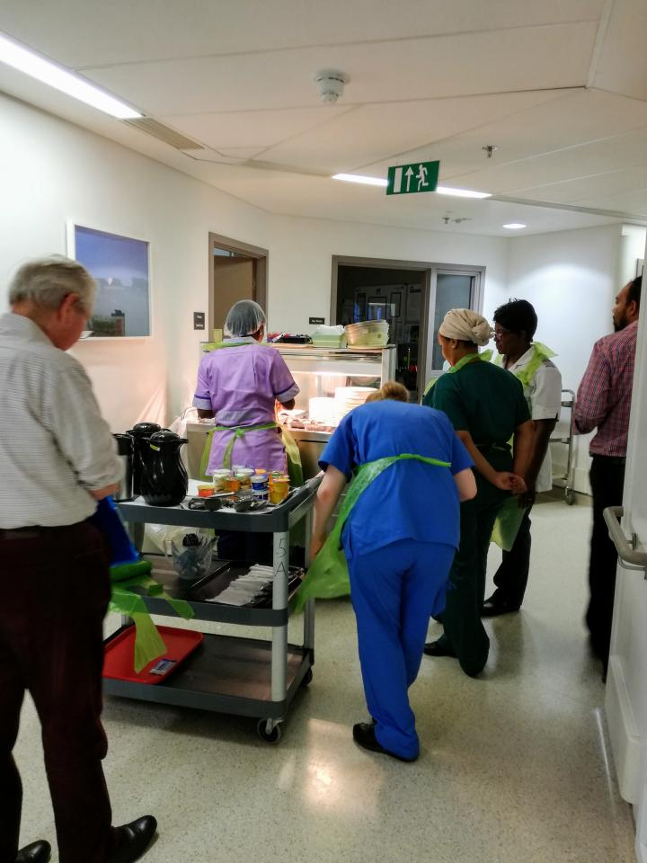
- Food was sometimes cold when it was served, and it was felt that the combinations on the plate could be improved.
Picture 1: Food being served on ward 5A.

Ward 5B (medical oncology)
Meal service observed | Lunch, 11-2pm, and evening meal, 5:30-7pm
Number of patients engaged | 7
Date of visit | 13/12/2016
It was possible to view the regen kitchen preparation in 5B for the lunch service. It was difficult obtaining patient feedback on this ward in the evening as many patients were tired and went to sleep either during or immediately after the protected mealtimes.

Staff oversight
- Not all permanent staff were trained in MUST, which was only offered ‘where necessary’. However it was felt that MUST was really successful.
- The Nutritional Link nurse had just left. A replacement has been trained although they had just been moved to radiotherapy, and so the ward was again, without this post.
- Healthcare Assistants were all trained in nutrition and hydration and all staff were trained in basic hygiene. Training was reported to be updated regularly.
- Signs were put up for when patients were post-surgery and coming off nil by mouth.
- Catering staff recorded food waste levels.
- Duty meal staff were asked about allergy information, specifically “How would you check the allergy situation if a patient notified you of a previously undeclared food issue?”. The duty team did not know where they would look for this, nor did they seem to know what process to follow, who to contact etc. An allergy chart (Picture 2) was on the wall, but was not referred to.
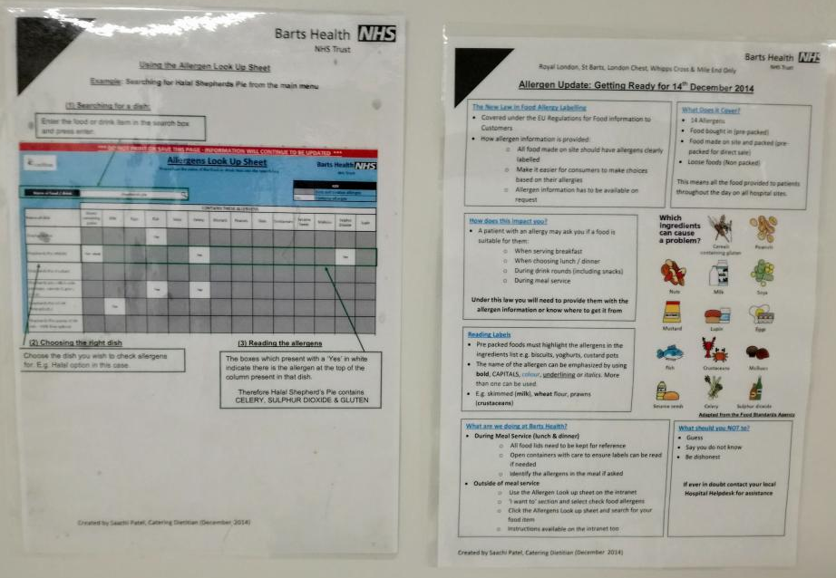
Picture 2: Allergy notice displayed on ward wall but not referenced by the lunch service team.

Kitchen
- There was an inconsistency of hair net usage amongst staff. Some did not wear hair nets in the food preparation area, though that could be because they were not specifically handling unpackaged food. It was noticeable that all Carillion staff who were serving food to nurses or patients put on hairnets.
- There were no windows in the kitchen area and there appeared to be poor ventilation as the area smelt unpleasant. The room was also extremely hot for staff.

Ward set-up and service preparation
- No red trays appeared to be in use, although one woman had difficulty opening the food packets and another had her arm in plaster and so could not cut up her food properly. It seems that these were not judged sufficiently problematic to warrant a red tray but could lead to difficulties eating not being addressed (especially if agency or temporary nurses were on the ward).
- Patients reported that staff were available to assist them to eat if required, but patients commented that the current staff shortage could make this difficult.
- We observed food being served to Beds 13-16 on the ward. The nursing assistant didn’t just leave the food with the patients – she made sure it was placed on the bedside table and the table moved into position near to the patient. One woman was lying in bed and she helped her get up and sit in the chair with her food in front of her.

“We’re well looked after here. The people make you feel better, the nurses and carers are really nice and they treat me well.” Patient

Variety and choice of food
- Patients were asked for their meal choices for the following day, in the evening. If new patients arrived during the day, it was possible to phone down their order to the kitchens by 11am to order food. Otherwise it was only possible to provide sandwiches.

“Pictures on the menu would be useful as patients and sometimes even staff do not know what a particular food is…There can be misunderstandings or I mean sometimes the patient may have the wrong expectation about what food is coming” Staff member

- The kitchen closed at 8pm. Any patient requiring food after that could ask for a sandwich.
- Patients were asked about breakfast: The breakfast food was all cold, comprising a choice of three cereals, fruit and (uncooked) bread with butter and jam/marmalade. No toasters were allowed because of fire safety concerns.
- The quality of food was perceived to be poor and was not appealing for patients.

“Patients have asked, and as a healthcare practitioner I’d like to see more healthy options on the menu. It’s really hard to get just a salad and yet this is regularly something people would like” Staff member

- If patients got hungry then staff offered them extra sandwiches and snacks.
- The 7th floor day unit had a much wider variety of sandwiches than the ward, although they are made by the same company, the choice on the ward was far more limited and did not change.

Food service
- Patients all appeared to receive what they had ordered.
- One patient commented that

“Some of the [individually packaged] food is hard to open as it comes in really hot trays. Patient”
- Patients were offered second helpings or sandwiches if needed, although not all patients were aware of the snack options.
“Plenty of snacks are available. We aren’t rushed to eat and are always offered a sandwich if we miss any meals.” Patient
- One patient was very happy with the food she had received and impressed that, having arrived from the Royal London the evening before she’d been sent with a sandwich box in case she missed the evening meal at St Bart’s. The lunch she had just had at St Bart’s was very tasty and hot. She had an arm in plaster and the nurse had helped cut up the food.

Additional comments
The kind and caring staff were praised by all patients.
‘Staff are lovely…They do more than their job. The people are lovely, they encourage you to eat and ask what you ate.” Patient

- Some patients from ethnic minority backgrounds felt that the meals were not prepared in the way they were used to and therefore were not happy with the food. Some people felt that the food was ‘not right for them’ (“it’s not what I am used to”) but appreciated the support given during meal times.
- It was felt that much of the food was not good quality or very healthy. It was simply standard and the cheapest version available. Many patients also reported that food was not properly cooked.

Ward-specific recommendations for medical oncology 5A and 5B
- To provide literature on the effects of chemotherapy and radiation therapy on appetite and taste, although there was a poster showing how to increase the calories in food (picture 3).
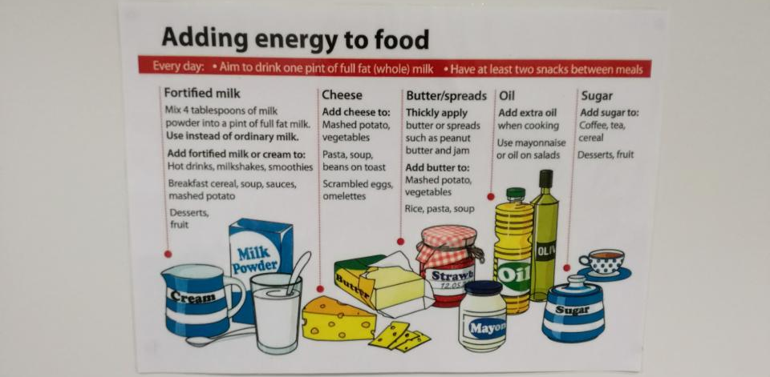
Picture 3: Poster in ward 5A, showing how to add calories to food.

Ward 5C and D (haematology oncology)
Meal service observed | Breakfast club, 7am onwards
Number of patients engaged | 6
Date of visit | 14/12/2016
‘Breakfast club’ included ground coffee and tea, along with pain au chocolat and croissants, and is available on Wednesdays, in wards 5c and d only. It was noted by patients that staff were very kind and trying to be helpful in providing appetizing food and drink, but were restricted in what they could offer. However, staff reported that patients enjoyed the breakfast club.
“It is nice to have a variation in breakfast as it is usually very bland”
Patient

Ward set-up and service preparation
- No menus or signs showing meal times were provided.
- Staff confirmed they verbally asked patients for their food choices. Some of the orders were literally recorded on a napkin and were almost illegible.
- Where required, food and liquid intake was usually recorded by the nurse (occasionally the catering staff), based on patient report. Some patients took responsibility for their own recording which was reported to be helpful for when they went home.
- There appeared to be little communication between the wards in respect of special activities such as the Breakfast Club and the Ice Cream and Cake Tea. These initiatives were restricted to individual wards. Not all patients were aware of these initiatives (or the Vive menu), despite in some cases, repeated stays on the ward.
- The food was distributed by bed number therefore there was a reliance on staff informing the catering staff if a patient had moved beds.
- The trays for serving were standard brown trays and looked very well used, which detracted from the experience. It was commented that “it would help presentation if food could be presented on a nice looking tray”.

Variety and choice of food
- Breakfast consisted of croissants heated before coming onto the ward, (not heated during rounds), a choice of four cereals, plain bread, jam, biscuits and milk.
- Patients reported that some mornings the milk was poured onto the cereals instead of being served separately.
- It appeared that once a type of food was included on the menu there was no variation within the different type of that food.
- The only tea offered was standard hospital tea. Many patients liked herbal teas and it was felt these could be useful for people with altered taste and/or poor appetite. Hot chocolate at night was very popular but not always available.
- There were numerous requests for toast.

Food service
- On 5C the trolley was operated and food delivered by a single staff member.
- Not all patients wanted a croissant or pain au chocolat for breakfast. However leftovers from the “Breakfast club” round were simply offered again at the 10am tea round.

Additional Comments
- The Breakfast Club was a new development, having been in operation for a couple of months, after obtaining funding for a ‘coffee and croissants’ service. Staff had previously suggested changes to enhance the experience further e.g. by using different trays, more sophisticated sugar pots, napkins etc. to make it feel more special. It was noted that patients on 5C and 5D were typically isolated to the ward (or even the room – even the day room is rarely used on 5C and more commonly used for discussions between care team and family) and therefore an occasional treat like Breakfast Club could make a huge difference to patient experience. It was felt that the usual requirement to ‘spend first and then claim reimbursement that might not be given’, is acting as an impediment to “trying different things” or experimenting to see what might work.

Ward-specific recommendations
- Milk should be served separately to cereals.
- The croissants were served in a small pudding bowl with a knife, butter and jam. Serving them on a plate would make them easier to eat.
- The croissants are heated in an oven and should be kept in the heated trolley for distribution so they are warm when reaching the patient. The softer texture made them easier to eat.
- All patients should be offered the choice of croissants and the special menu when it is appropriate to their treatment.
- Trays could be replaced with something more likely to improve presentation of food – could this be through sponsorship by a retailer or tray manufacturer?

Ward 3A (cardiac)
Meal service observed | Lunch, 11-2pm
Number of patients engaged | 8
Date of visit | 14/12/2016
Ward 3A is an emergency ward. It was difficult to obtain feedback as many patients had only recently been admitted with acute coronary issues and in some cases were too unwell to eat. In the future it may make sense to survey and interview patients in ward 3D or 6D after they are ‘stepped down’ from the CCU. There was very good feedback on care, treatment and staff:
‘This ward is excellent, the staff here are excellent and the care here is excellent…I stayed at a private hospital recently and paid £15k, I would say that this hospital is better than the private hospital.’ Patient

Staff oversight
- The dieticians were entering the wards and spending time training nursing staff on MUST. We were informed that they spend an hour at a time with different nurses and this way of informally training staff was being rolled out across all wards.
- We were informed that this ward had a Nutritional Link Nurse, but nobody knew their name and they were not available on the day of the visit. We were informed that they had not undertaken any training with other staff members on the ward.
- Healthcare Assistants’ attendance on nutrition and hydration training was reported to be down to the individual’s choice.
- The serving trolley was not in a suitable place in the corridor as when a patient trolley needed to pass it had to be moved to allow it to pass.

Ward set-up and service preparation
- There was a notice on the main door saying that this ward operated a ‘protected meal time’, with times.
- Five staff members supported the lunch service- the service was well managed by a nurse that oversaw the lunch service on that day.
- The staff member serving the food from the food cart was not wearing a hat or gloves during service.
- The staff seemed unsure how many patients were users of ‘red trays’. Initially we were informed it was one patient; however later during lunch service it was discovered that there was a second red tray patient. The high turnover of patients on this emergency ward necessitates effective communication to ensure no ‘red tray’ patients are missed.
- Little time was spent by staff in setting-up patient’s trays/tables prior to the lunch service or to ensure that’s patients were in comfortable position to eat.
- The patient orders were written on a napkin on the food trolley and patients identified by bed number.
- A lot of information in respect of patients special needs appeared to be ‘in people’s heads’ rather than written down.
- There were problems with patients getting food they had not ordered. Some patients that had been admitted in the morning did not receive any food.
- Patients were not asked if they wanted to wash their hands prior to lunch service, but wipes were provided.

Variety and choice of food
- Menus were not provided. Representatives were informed that staff read out the menu items to patients the night before or if newly arrived, in the morning.
- Some of the nurses were not aware that the food trolley had salt, pepper and sauces (ketchup/ mayonnaise). One of the nurses suggested that salt and pepper should be put on all trays as standard when serving lunch, as “patients always complained about the lack of salt”. One of the nurses said she had informed patients that they don’t have salt, as she thought they did not supply salt to this ward- she was surprised to hear that they had everything on the food trolley.
- There was not enough food on the food trolley to feed all the patients on the ward, due to the five new admissions - staff went to the next ward to get extra meals.
- The menu was restricted and on a two week rotation which was reported to be very dull for those that were unable to get out of their rooms e.g. one patient struggled to find something to eat at times.
- A patient on a soft diet complained of very limited options and bland food.
- Food was often reported to be cold or lukewarm. However it was noted that the cooking of vegetables had improved and they were now less soggy.

“The general look of food is not good and we don’t have the ability to change how it is presented” Staff member

- Second helpings were only offered if there was enough food.
- Staff felt that due to the nature of this ward (e.g. people need to eat healthy), there should be more salad options. Salads were not available every day.

“I have had training on MUST, Hydration and Nutrition and know how important Nutrition and hydration is to patient recovery…the main problem is the menu, at this ward people need to eat healthily – salads etc. Instead we get things like Tiramisu, which is high in fat. We need to make the menu more relevant for the patients on this ward” Ward nurse

Ward specific recommendations
- One patient commented that if they were asleep when staff came round to take their order then they simply chose for them, which led to people often not eating it when it arrived. It was recommended that patients were asked if they wanted to be woken up for food, and the bed ‘labelled’ as such.

Ward 4D and E (cystic fibrosis and respiratory)
Meal service observed | Lunch, 11-2pm
Number of patients engaged | 8
Date of visit | 15/12/2016
It was noted that patients with cystic fibrosis typically needed to eat 3000 to 4000 calories per day and all patients were allocated their own dietician. Patients stayed in individual, isolated rooms with negative air pressure to filter out bacteria. Healthwatch City of London representatives observed lunch being served on the non-air filtered ward.

Note
Cystic Fibrosis patients were offered up to three vouchers (provided at £6.50 per meal) which could be used to obtain supplementary food at food outlets within the hospital e.g. Costa Coffee.
Patients often had to stay at hospital on a regular basis and some chose to have food brought in to them, especially if their taste had changed and they had specific preferences. Some had started to use the hospital wi-fi to order takeaways e.g. pizzas. It was unclear whether there was an approved list of takeaways – some staff thought this was the case, others knew nothing about this.

Staff oversight
- Staff were made aware of the individual patient needs as part of admissions. MUST training was updated once a week and was considered to be good. The Nutritional Link Nurse reaffirmed the success of MUST.
- Not all staff were sure who the Nutritional Link Nurse was.

Facilities
Facilities in the room of the cystic fibrosis patients were thought to be good, and were appreciated:
- The food and tea/coffee facilities in the pantry were only available for patients (and not visitors). Several high energy items were available for the extra calories the patients required.
- Many rooms had fitness equipment in them for patient use in line with the recommendation to exercise.
- All rooms have their own fridge for food and medications.
- An iwave machine was provided to enable patients to heat up food out of hours. This incorporated a barcode scanner which gave information on heating times. However, there was a requirement for a member of staff to temperature probe the food before it was eaten.
- A toaster was present in one kitchen despite other wards not being allowed this.

Ward set-up and service preparation
- New gowns and gloves were used for each person that entered a side room to see a patient, including to serve food.
- The serving staff wore gowns but did not wear gloves. They washed their hands in between each patient.
- Patients were not asked if they wanted to wash their hands before each meal although wipes were provided.
- Nursing staff did not like having to go round and talk through the choices with the patients; they wanted proper menus so patients could choose themselves. Patients having trolley food submitted their meal cards one day in advance.
- Sandwiches and snacks were offered soon after the meals were served.
- There were occasional ‘Come Dine with Me’ evenings where guests could eat with the patients.
- Patients who were not eating well were served food on a red tray. Patients with small appetites are encouraged to eat little and often. If they were not eating enough, they were given a drip feed overnight. At the time of our visit, five patients had feeding tubes.

Variety and choice of food
- Soup/fruit juice/fruit was served around midday then the main meal was served afterwards.
- Patients on one part of the ward could visit the pantry themselves and had a toaster. Patients on the other ward had to ask for snacks and there was no toaster.
- There were frozen meals available in the freezer of the pantry, which could be cooked in the iwave machine.
- High energy snacks were available to patients at any time in the ward pantry. Bread, cereals, fruit, juice, Pot Noodles, Kit Kats, milk and nutritional supplements were available as snacks.
- Second helpings were generally available to those that wanted them, although many younger patients preferred their own food.
- Menus were on a two week rotation and for regular hospital attendees that meant seeing the same options come up time and again.
- Nurses felt that the day staff should be doing the breakfast service as they were new on shift and fresher.

“If you have spent the night turning people and helping them go to the loo it is unhygienic to be then handing out breakfasts. It’s not acceptable and is the first hospital I’ve worked at where this happens. Also, if we are giving out breakfasts who is helping the patients?” Staff member

- Healthcare Assistants felt that the meals could be improved and if food was better patients would be more likely to eat meals on the ward.
- The hospital food in general was reported to be unappealing to the younger patients.

Additional comments
- The breakfast was described as too early by staff (6.30-7am). This meant that people could be having breakfast with the person in the area next to them washing or going to the toilet. It is also medication time and the ward is very busy.
- One older lady wasn’t aware of the snacks or availability of second helpings and only started receiving snacks when she spoke to the dietician and said she wasn’t receiving any. She had also missed soup whilst having a test and was not offered any:
“Yesterday I missed sandwiches as they were given to the person opposite. I asked for another one and was told that if you keep asking you’ll be told you’re fussy.” Patient

- One younger patient said he loved food but rarely chose to eat the meals offered on ward, preferring to use his vouchers to eat in the Level 2 hospital restaurant which he liked. The only challenge he had was getting to the restaurant early enough to get breakfast. In the evening he often left the hospital to buy food.
- Patients reported the food was not hot when it arrived and often unappealing.
- Again, there was a preference for toast from those patients that did not have access to the toaster.
- Pictorial menus were requested.
- Younger patients were spending large amounts of money on takeaways (£300 in 3 weeks as an example).
“Staff helped me order from Just Eat and the food was delivered to the ward door and collected for me by a nurse. I don’t do this often though.” Patient
- A request was made for sandwich fillings in the pantry and sandwiches available in the kitchens as well as snacks.

Ward specific recommendations
- A menu that is more varied and appealing to younger cystic fibrosis patients should be introduced to avoid the need for patients to be spending large sums of money on takeaways and food externally. The prevalence of takeaways also risks undermining the expertise of the dieticians.
- All patients need to be informed of the extra snacks available and how to access food if they are undergoing treatment.
- It is recommended that toasters are made available to patients on both sides of the wards – at the moment only one of the kitchens has a toaster.
- Breakfast should be delayed to ensure it does not overlap with people washing/using the toilet and receiving medications. Day staff to serve breakfast rather than night staff.

Update
There is a new catering contract starting at St Bart’s in April for the whole hospital where there will be individual picture menus for each patient based on the ward. Each ward will have a Ward Hostess who will take meal orders and serve meals. Patients will be able to order their meals a couple of hours in advance rather than the day before. There will be an a la carte menu with daily specials.
Healthwatch City of London was informed that ‘nutrition is less important for Cystic Fibrosis’ and that is was ‘more important to have as many calories as possible’. Healthwatch City of London was informed that the new menu will be tailored towards maximising calories, rather than nutrition on this ward.

Staff concerns
The catering staff were concerned about the new contract and how they were going to be moved to a new company. There was a lot of uncertainty and lack of information which was of real concern to staff. It was felt information could be provided to allay these concerns especially as the new contract was running in other parts of the Trust. They were aware that Serco would take over from Carillion in April 2017 but had heard nothing from Serco and were naturally anxious about what it would mean for their jobs.

Next steps
This report will be sent to the Nursing Director and the Head of Dietetics at St Bartholomew’s Hospital for their comments and a final iteration circulated to the St Bartholomew’s Hospital Board, the Medical Director, CQRM and the Patient Forum.
This will report will be used as a baseline and re-visited in 9-12 months to review progress when the new catering contract is in place.

Acknowledgments
Healthwatch City of London would like to thank the patients, ward and catering staff at St Bartholomew’s Hospital for their valuable contribution to this report, as well as the Healthwatch City of London representatives that took part in the visits, including Caroline Chalmers, Reno Marcello, Elizabeth Sparrow, Steve Stevenson, and Shamsur Choudhury from Healthwatch Tower Hamlets.
We would also like to thank Rashmi Soni, Dietetic Clinical Lead for Bart’s, for making arrangements for us to carry out the visits and Rose Fairweather, Dietitian, for the training on nutrition at St Bartholomew’s.

Clarity is needed as to whether salt or a salt substitute was provided.
Representatives include lay members of the community (local residents and volunteers) that received training in undertaking Enter and View visits.
NOTE: There had been a ‘mock’ inspection the previous week and to some extent there was a feeling of being ‘over inspected’ therefore the visits were described as obtaining information for the new contractors.
Breakfast Club is funded by the Bart’s Charity.

