Donny Brook - Enter and View Report

Service: Donny Brook Extra Care
Provider: Creative Support
Date / Time: 16th August 2016 / 10.00am -13.30pm
Healthwatch Tower Hamlets Members: Dawn Anderson, Pauline Canning
Healthwatch Tower Hamlets Staff: Shamsur Choudhury
Lead provider contacts for the visit: Thandi Murambiwa, Deepika Thapa
Address: Donny Brook Court, 319 Old Ford Rd, London E3 5NT

Purpose of visit

1. To gather resident’s feedback on their experiences of living at Donny Brook and the care provision received. The feedback discussions with residents were based around the following areas:

- likes and dislikes of living at Donny Brook
- How they feel about the staff and how they treat them (privacy and dignity, communication-language support),
- If they receive care from same staff members (continuity of care)
- Do they feel they have sufficient staff support and daily interaction with staff (one to one, staff presence)?
- Do they feel safe? Are buzzers responded to quickly?
- what activities they take part in and how they feel about these activities (are they tailored for their needs)
- Cleanliness of their flat (laundry and general cleaning)
- Do people from the community visit them and offer them social time (one to one interaction)
- how they get involved in deciding on provisions and activities.

2. To gather resident’s suggestions for improving the service e.g. What they would like the care home to provide; (i.e. additional activities/ services) or what they would like to see changed.

Information on the service (discussed at meeting with management present)

- Donny Brook Court is an extra care sheltered home, this means that residents are deemed suitable to live independently but receive some form of care daily based on their individual needs which enables them to live independently. Most residents have moderate needs and the type of support residents receive is personal care, medication, meal time, shopping, laundry, housework, keeping appointments, liaising with professional such as GP, Occupation Therapist, CPN, housing officer and helping with engagement in different activities. If there is no one to escort resident for appointments, staff support the resident to attend rather than miss the appointment.
- The number of hours of care each resident receives is based on their personal needs (i.e. someone with physical disability will get more hours of care) and in decision with their social worker, the majority of residents receive 12.5 hours per week. All the residents have a care plan and they are also attached to a key worker that reviews their care plan every six to eight weeks.
- Donny Brook Court Extra Care is managed by Creative Support. Creative Support took over the management of this extra care service from Sanctuary Care in November 2014 as part of LBTH Adult Social Care retendering process. Creative Support is a national care agency and currently works across 63 local authorities. Since November 2014 they have taken over four extra care provisions in Tower Hamlets from Sanctuary Care, they include Sonali Gardens, Coopers Court, Donny Brook and Duncan Court.
- Donny Brook Court has 40 flats and at the time of visit there were a total of 39 flats occupied and receiving care support from Creative Support, one of the rooms was empty as they are waiting for a referral from a wheelchair user as the room is wheelchair accessible. The building is owned and managed by Circle 33 (Old Ford Housing).
- Staffing ratios: Day shift, AM- 6 staff and PM-4 staff, plus support coordinator and Project Manager. Nights– 2 waking staff
- Staff are supervised every 4 to 6 weeks or sooner if necessary.
- Training: All mandatory trainings are provided in- house as required staff receive training around the following: Supporting residents to take medications, dementia awareness, food & hygiene, handling and lifting. Training is provided in house by Creative Support. When new staff are employed they shadow the project manager and they have supervision meetings every four to six weeks, the supervision meeting covers the following areas: if new caring staff have any concerns, improvements that could be made, challenges with working with residents, how to address residents (e.g. with dementia, incontinence, etc.). Staff have attended 8-week course for dementia support for extra care housing (TH CCG). Also staff have annual appraisal and annual specialist supervisions on Safeguarding, Medication and dignity.
- Activities: Creative Support has an activity co-coordinator (Francis) that supports all of their five contracted services in Tower Hamlets. Currently they have activities such as ‘mum and bubs sessions’ (local mothers bring their babies and engage with residents)’, games, Boccia, day trips, Age UK facilitate activities sessions 3 times per week. The activity coordinator jointly works with local community/organisations such as Age UK, LinkAge Plus (Befriending and Activities) and Alzheimer’s Society
- Involving Residents: They hold monthly meeting with residents (Tenant Meeting) and consult residents on such things as activities to be organised. Needs Review: This can be a yearly review or as the care needs changes, they arrange a joint meeting with social service, others professional and family.
- Family/ Carer Involvement: Family members are encouraged to get involved from the beginning, they are invited to view the place and participate in writing care/support plan. Family members are also invited for all review meetings if the resident wants. They are also encouraged to attend resident/housing meetings. Family members also act as advocates for service users. Family members also support service users with day to day tasks such as shopping.
- Challenges included the working with the staff group (tuped from Sanctuary Care) to embed a positive and accountable attitude to the service. This has included reviewing a lot of practice and introducing changes and new procedures. This was challenging initially for staff.
- Hydration and Nutrition: Staff always record what has been served to the resident and what they eat during their visits in the care notes. If someone is not eating well, the staff raise the concern with GP and monitor the diet intake.
Observation of Enter & View Representatives

- The environment of the home (especially communal areas- walls and carpets) seemed cleaned and well maintained
- Residents seemed to look like they were well cared for, most of them looked clean and well dressed.
- The care provider seemed well networked with the local community and community groups- this seemed evident from the activities taking place on a weekly basis.
- There was good information on local services on the noticeboards.
- A gas meter box was open on the second floor - the CQC have highlighted this as well and it seems that certain meter boxes have not been fixed.
- There was a big garden with a small vegetable patch, plants and flowers. Overall the garden did not seem to be well maintained, the garden furniture was dated and there were two wooden garden benches that were broken (see attached pictures), this is a potential safety hazard, the garden shed was untidy and also needed repair. The provider mentioned that it was the duty of the owner Circle 33 to maintain the premises as well as the property in the garden.
- There was a mums and toddlers group session taking place in the garden. The mums said they enjoyed coming to Donny Brook and the staff said that were CRB checked and liked coming to Donny Brook, they said they help on a voluntary basis with activities and events wherever possible.
- Activities posters were displayed on all floors and near the lift area.
- There was an issue with the buzzers in the resident’s flats. The buzzers were not working for some time up to a couple of months. The manager explained that the system had to be ‘patched up’ for it to work again and that the system is now old and needs upgrading. All buzzers and red pull cords in the flats are now working but the manager and care staff said that they ‘have to keep an eye on the situation’.

Residents Feedback

Resident 1

Spoke to a couple they said that they were not interested in activities. “we go to the market”. They said there were enough staff and they were very happy and there was nothing that they did not like. “the staff are first class”.

Couple- Male and female/ White British

Resident 2

“The staff talk but they don’t talk much, they don’t talk to you. It would be nice to have a chat with someone. I went to the Millennium gardens with the Day Centre, when I came back to Donny Brook, they didn’t speak to me. I was put in the garden, I didn’t want to go in the garden, they didn’t ask me if I wanted to sit in the garden. I can’t see what is around me. I see shadows. My family and friends visit me, I don’t know who to report things to, my buzzer wasn’t working, I told a staff member but no one got back to me, it’s working now. I have 1 ¾ week of services, I feel that I have to fit around staff times, rather than they fit around me. They are too busy...I have waited from 30-60 minutes when I have buzzed for help to go to the toilet.

I go to St Hilda’s, everyday apart from Tuesday. I like doing quizzes. I don’t want to wake up because I can’t see, I want to see my husband, he’s dead you know. I want to talk to someone on Sundays”.

Female/ over 65/ White British

Resident 3 (spoke to two residents in the communal garden)

Resident 1 said: “My buzzer was not working you know, it’s working now, it was off for months. We reported it but nothing happened, then one day they came back on”.

Resident 2 said: “I go to Tesco’s, the market, I do some of the activities but they are not cheap you know. I don’t have family visit me, I’m worried about my befriender, I’ve not heard from her, maybe she’s gone away, I don’t want to bother her, but maybe I’ll ring her. I get worried you see… I’m not happy with the garden furniture, it’s not nice. Age UK have better gardens; did you know that? beautiful they are”.

Resident 1 said: “That’s because they look after them. I have a say in how things are run there, we have meetings in the hall, we gather round about how things are, we get involved”. We go to Appian Court; they have fun things there”.

Resident 2 said: “Look at the babies. I don’t agree with them coming in here, I can’t say anything though. I don’t agree with it, as it might upset some people especially with dementia, it’s not right”.

Both Female/ Over 60’s/ White

Resident 4 (interviewed in the communal corridor, main reception area)

She said “This place is nothing like it used to be, not as good. I’ve got to be careful what I say, no, yes, no proper person in the office. My friends have died; I don’t do activities nothing interests me here. “My buzzer wasn’t working, sometimes it works sometimes it doesn’t. You have family that visit, I get privacy, you don’t feel safe. Representative asked her what it is that doesn’t make her feel safe. She said “can’t say, nothing particular to talk about”. “The Southend trip was too expensive for me, they have cut back on staff, not so many now”.

Female/ Over 65/ White

Resident 5

Management has been crap, they have no idea of how to meet my needs...I would like to see my flat cleaned twice a week and get the place mopped up a lot more…currently there is no manager at this place, residents are not informed when changes are happening, I should be given a contact list of key individuals that I can contact. When Sasha (the previous manager) was here… it was good, she would always answer my questions and respond to my requests, now that she has left no one responds and there is no one to speak to. The staff come and see me four times a day, for around 10 minutes...I like the staff members, they are like family but they don’t have much time to talk to me, just do their thing and go …I would very much like for them to talk to me!! Staff attending to me can be a hit or miss, I prefer to take my tablets at 1pm, staff either come too early or come too late.

I generally feel safe here, although sometimes it takes quite long for them to respond when I call the buzzer in an emergency… I think I could do with a pendent, that will make me feel safer.

I don’t take part in activities, people here are not sociable, my next-door neighbour is alright, so we keep each other company. I can do most things by myself I do my own shopping and visit the GP myself.

I would like for them to increase the amount of times they come and clean my flat.

Male/ 80’s/ White

Resident 6

I like living here, the carers are nice, they give me a shower, make me sandwiches; clean my flat, take my clothes for washing…sometimes I go to the party when they organise them…I prefer to sleep and I tend to sleep a lot…I don’t get bored as my daughter comes and visits me.

There are lots of different carers, but mainly the same ones come around…I don’t mind seeing different carers as long as they know me. Staff come and see me four times a day, they always seem busy, they don’t talk to me. Sometimes I use the buzzer, they usually come within 10 minutes, I am happy with that.

I would like someone to help me cook, currently all I do is have sandwiches…the carers help me with my shopping, they do my shopping every Thursday...I tell them what I want and they get it for me…I am happy with this.

I would like people to come and see me and help me to cook..., too talk to me…my daughter comes sometimes, but she can’t come every week…I would like need company!!

I don’t like one of my neighbours, he keeps knocking on my door when I am asleep and he always wants cigarettes…I would be very happy if he stopped this...I have told him not to knock on my door.

The representative informed this resident of the ‘meals on wheels’ service’ she said that she did not know about this service and wanted the manager to give her more information.

Female/ 70’s/ Israeli

Resident 7

I been living here three months; I don’t mind living here it’s better than the other ones I have seen…it’s the best in East London…the size and the layout of the flats are good…I like the flat. The carers come and see me twice a day, they clean my flats, do my laundry and check if I am ok, I able to shower myself and do the shopping…when I am eating my dinner I don’t like being disturbed…there are 6-7 staff members, I know them…the staff are really nice, they help and listen to you, make you cups of tea.

I have used the buzzer twice; I fell twice from my wheelchair and had to crawl to pull the emergency buzzer…two nurses came quickly…it would be helpful to have something closer in an emergency...

They provide a leaflet that tells you about all activities taking place, we get fish and chips on Thursday…I usually go down there and have that…it’s a nice piece of cod...good size!!

I have everything I need here...my daughter comes and cooks for me…I feel lonely that’s because I am apart from my wife…but I call people up and talk to my wife whenever I need to, she is happy to keep me company…

I am content here, once I get my legs I will be out of here…

Male/ Over 70/ White British

Representative Notes: Representative informed the resident of a ‘pendent’ that some providers use for the emergency buzzer…the resident said that he has not been offered anything like this and feels that it might be helpful for him have especially in a situation of falling out of his wheelchair.

Resident 8 (Carer feedback - resident’s daughter)

Very good service, they are nice and caring people…my mother has been living here for 5 years…it’s got better since Creative Support took over, there are more activities, better care and service and they come and attend to my mum four times a day…the staff are same as before, they are ok...we are happy with the flat and have no complaints, overall happy!!

However, I am not happy with Meals on Wheel service, we cancelled them as they kept coming too late and she was not eating right…now we cook her food…

Female/ 80’s/ White British

Resident 9

Been living here for around 2 years, I quite like living here...the people that come to help you every day are nice, they come about three to four times per day…they don’t mind doing things for you…they make me tea, sandwich clean my flat, do the washing, make you dinner and give me medicine…they are friendly and helpful…however they are always busy...it would be nice to speak to them a bit more. My nephew comes and visits me at least 3 times a week and a friend from church comes and sees me…but it would be nice to see more people and talk to them…

I don’t go downstairs (referring to the communal lounge), waiting for my eye operation, after the operation I will start going again...they do tell you what’s happening downstairs.

I feel safe here, there are always people coming to see if you are ok. I have used the buzzer in the past and they always respond very quickly... maybe within 5-10 minutes.

Female/ 70-80/ White British

Resident 10

This places drives me mad, some of the carers in this place are not worthy of the label ‘carer’…one of them made up lies about me and she talks about me in the corridors...she openly admits that she lied about me…90% of the carers are external agency carers. They don’t wash the dishes properly, last Sunday they just put the dishes in the cupboard without washing it, their hand hygiene is terrible they touch things without washing their hands and don’t wash hands after taking off gloves…they walk out on you when you make a request, last week on four occasions they walked out on me, apparently their 30 minutes was over, if they are late then they should make up the time!!

Because of these issues I only receive 4 hours support from Creative Support, the rest comes from Sanctuary Care. I am waiting for a PA; my social worker is trying to arrange this…its taking them ages.

It was me that set up the Boccia activity and linked this place up to the lady from Age UK, I thought the people could benefit from it.

Male/ 20-30s/ White British

Representative notes: this representative has on going issues with the provider and asked Healthwatch to advocate on his behalf, Healthwatch have asked him to liaise with Adult Social Care Commissioning Team and to relay his concerns to his social worker.

Feedback provided after the visit- 6th September 2016

Two carers came to the Healthwatch office to give their feedback as they did not get an opportunity to provide feedback on the day of the visit, they informed us that they were not aware that Healthwatch were visiting and found a note in their sister’s room which stated that Healthwatch would be visiting , they highlighted that it is important that carers are informed by providers of such visits in advance, this will give carers the option of deciding if they should come on that day to provide their feedback.

Carers feedback:

- Carers do not put Fixodent in her sister’s teeth and as a result their sister loses her dentures regularly; they have been asked to do this and carers keep forgetting to do this in the morning.
- Their sister wears a hearing aid and when batteries finish carers do not actively make the effort to change the batteries, as they take no notice of whether she can hear or not…
- Their sister goes wondering in the night and knocks on neighbour’s door (has advanced dementia), this is an issue for the neighbours. To overcome the situation, it was suggested that they put a sensor alarm on the door, this will inform night staff that she has left her room and alert them to come and take her back to her room…the carers commented that the sensor came and it was installed and they were not informed of this and more recently the sensor has broken and sitting on a table in the kitchen and has not been fixed in a long while. They would like this sensor to be fixed asap and this is proving to be difficult, they mentioned that they will raise this with their sister social worker. Any how they are not sure what night staff do as their sister still goes wondering...their main question around the sensor is, who will repair it and when?
- They mentioned that they don’t do any activities e.g. activities on Thursday does not happen and activities that take place are not suitable for everyone.
- Staff do not engage with residents
- Staff are not sensitive to her sister’s dementia, e.g. staff laugh when their sister swears
- No one opens the door in the mornings, their sister goes to a day centre (Russia Lane) every morning and gets picked up a transport, the person picking her up always complain that no one opens the door for him.
- Sanctuary Care staff are very good.
- There has been no improvement since Creative Support took over.

Feedback Summary (based on resident feedback, representative observations)

- There were lots of positive feedback on the care staff, a resident commented that ‘staff are like family’ and another said that staff are ‘first class’. Only one resident (resident 10) has had bad experiences with staff. A few carers also commented that the staff are not providing good enough care to their sister e.g. they are not doing what they have been asked to do such as putting Fixodent on their sister’s dentures.
- A lot of residents seemed to be attending day centres and other centres during the day (e.g. Appian Court), this was good to see as it demonstrates that residents are keeping active and not just sitting in their flats waiting for the day to pass.
- Residents seemed to like the flats, one resident said he saw many extra care homes and felt that this was the best in the borough.
- Compared with other extra care and residential homes in the Borough, this extra care service seems to be keeping active in linking up with community groups and getting local residents involved.
- Loneliness seems like a key issue for residents. Residents commented that staff do not engage and speak with them actively, they seem too busy. Residents would also like people to come and visit them (befrienders).
- A few residents mentioned that there has also been reduction in staff numbers since the new provider has taken over.
- Some residents commented that staff can take a long time to respond to buzzers. A few residents have fallen over twice and commented that the emergency buzzer was not very accessible in these situations.
- Resident commented that the organised daytrips are expensive and sometimes the advertised activities do not happen. Also, there needs to be activities that meet the needs of different residents.
- The absence of a care home manager has left residents not knowing what’s happening and who to contact if they need anything.
- The provider has taken active steps to implement CQC action plans. (see page 10)

Provider response to ‘Concerns’ raised on the day of the visits:

Residents Emergency Room Buzzer: There was an issue with the buzzers in the resident’s flats. The buzzers were not working for some time up to a couple of months The Manager said that buzzer situation was now resolved but could not guarantee that the service providers would maintain the system in a timely manner if it happened again.
Reporting residents housing concerns: The Office Manager produced a repairs manual in which all repairs requested by residents are logged and weighted and if necessary escalated within a specific time frame. She said that residents are updated on the progress of a repair and that they are dealt with in a timely matter, however there may be a ‘hold up’ at Housing provider end which she said was very frustrating for the staff and residents.
The Garden: Overall the garden did not seem to be well maintained, the garden furniture was dated and there were two wooden garden benches that were broken (see attached pictures), this is a potential safety hazard, the garden shed was untidy and needed repair. The Office Manager said that the condition of the communal garden furniture was not acceptable but she had no control over the maintenance of this as it comes under the housing providers contracted maintenance service agreement.
Recommendations (based on E&V Representative, resident feedback and observations)

- We would like to suggest that the provider offer pendants (as emergency buzzer) to residents that might have mobility issues (in a wheel chair).
- We would strongly urge that the furniture in the garden is replaced as it poses a health and safety hazard- this concern needs to be raised with the housing provider (Circle 33). The care provider should also take active steps to make the garden accessible as it is a vital part of resident’s experience of living there e.g. residents can go and socialise in the garden, do activities, etc. There are organisations such as East London Business Alliance (ELBA) that can support the refurbishment and cleaning of the garden area.
- We would recommend that day trips/outings are affordable to residents- residents should be consulted on such things as cost as part of organising process.
- To tackle loneliness, there should be initiatives that offer residents more one to one time with staff e.g. one care home we visited has a scheme called ‘resident of month’, once a month every resident gets special treatment for a day e.g. staff take them out, do somethings that they like, etc.
- The managers should encourage care staff to actively engage with the residents.
- The management should provide better information to residents so they feel like they are in the know e.g. provide contact details of Creative Support managers, what is happening in terms of recruiting a new manager, etc.
- To better inform residents of befriending support and any groups that can help or support residents to tackle isolation and loneliness e.g. take people out, come and help them cook.

Questions for provider (Response from Provider)

CQC Action plan/ issues raised in report:

People not receiving hours allocated by LBTH

- Care logs completed by care staff now demonstrate the commissioned hours for each client. Where this is not the case, the reasons will be clearly recorded in the care notes and MAR sheets and is followed through by Senior staff at the service
- all outstanding reviews have been carried out and the service is now 100% compliant in this area. Although this has been the case, the Registered Manager and the Project Manager will continue to work with clients, families and social services to conduct reviews in response to client changing needs.
- All Care plans have been reviewed in order to update the changing needs of the clients following the reviews held. Discrepancies in the care related documents have now been removed. There is now clarity and only one Detailed Breakdown of care which shows what care people should receive and at what time. All care related documents are now signed and dated in line with the recent reviews carried out.
- All Risk Assessments have now been reviewed and updated to reflect client needs. For example, it has been highlighted where 2 staffs are required for Manual Handling. The client with the risk of choking is now being checked during meal times.

• Recording of Medication

- Medication Administration Audits are consistently being carried out with identified timescales. These are being carried out in the form of daily spot checks and monthly audits.
We have met with the family member and discussed the family their responsibilities in relation with supporting a particular client with their medication needs. Following on from this meeting the care documents and MAR sheet signing are now clear and clearly defines
- Medication Competency Observations of staff
The managers will continue to observe staff competencies with medication administration in order to ensure that they continue to follow medication administration procedures and sustain improvements in order to minimise errors.
- Following on from the Inspection report, each staff member has been issued with a Management Instruction which highlight the expected standards of care delivery and documentation. The Management Instruction included the requirement to follow correct procedures for care logs and to highlight, reflect and cross reference client care needs, commissioned hours and to detail the actual care and support given. This ensures that staff have clarity on the required expectations and standards.

Questions:

• Who is responsible for administering medicines? How are medicines spot-checked and audited? This was requiring improvement from CQC report. have staff attended medication administer refresher course?
After an assessment if a resident is not able to safely administer his medication. Staff help with prompting/administering medication. Staff on each shift carry out spot check on the floor they work, this highlights if there is gap or missed medication immediately. Senior team aims to do 20 medication audit each month. For any discrepancy, we contact GP, inform social services and work with staff member to stop this from happening again. All staff have medication training as it is mandatory. No one can administer medication without the training and being supervised by the senior to start with.

Important Information for Management

- We expect management to provide an ‘Action Plan and Response’ on the raised issues under the ‘Recommendations and Suggestions’ and ‘Questions for Management’ headings.

- Copies of this report will be circulated to the, LBTH Adult Care Commissioning Team), CQC and will also be available to the public on Healthwatch Tower Hamlets website.

Healthwatch Tower Hamlets representatives and staff would like to thank Thandi Murambiwa and Deepika Thapa for making all the necessary arrangements in organising the visit and for helping us during our visit.

Disclaimer

- The observations made in this report relate only to the visit carried out at Donny Brook Extra Care, which lasted for a total of two and half hours in total.
- This report is not representative of all resident views; it only represents the views of those who were able to contribute within the restricted time available.

Pictures

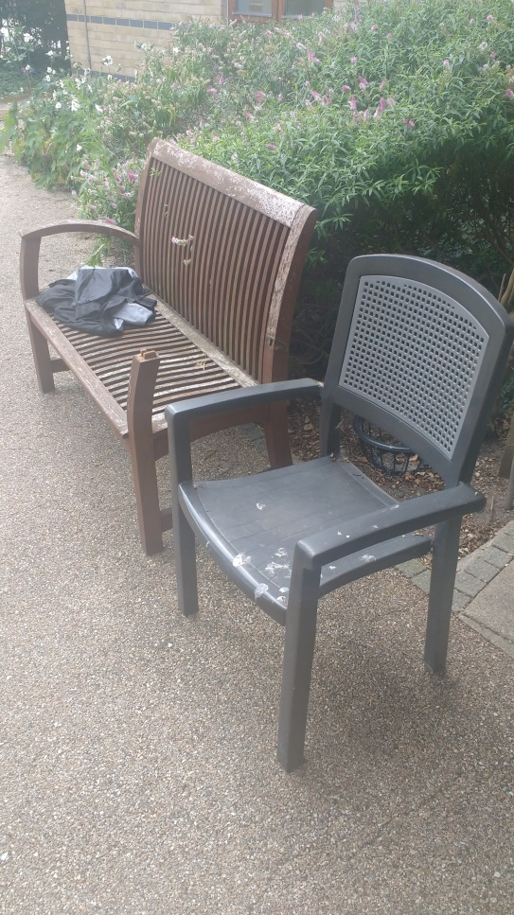

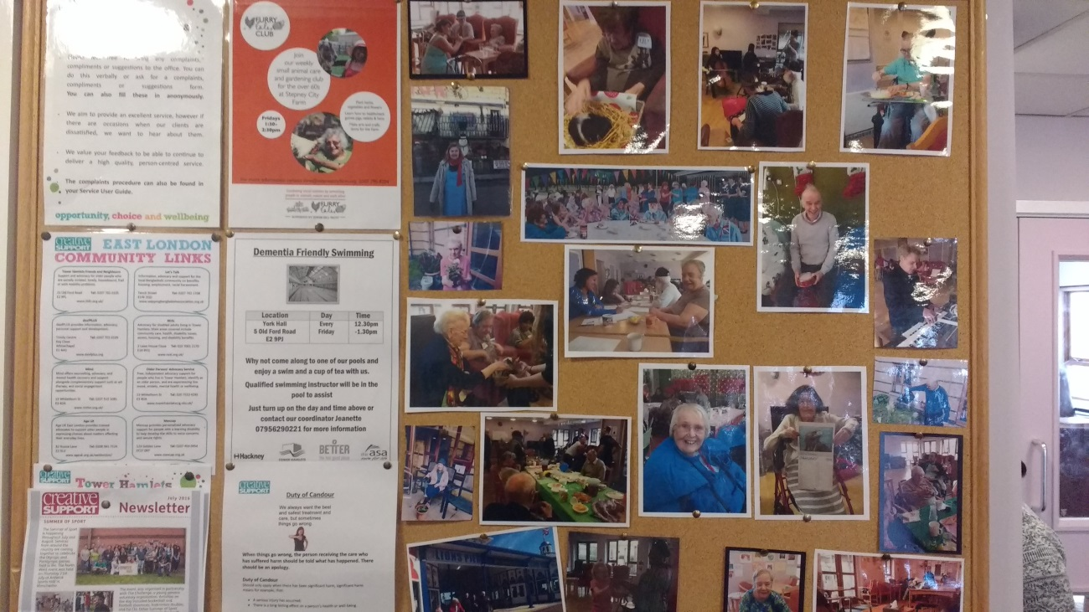

Provider Response (Creative Support)

- We would like to suggest that the provider offer pendants (as emergency buzzer) to residents that might have mobility issues (in a wheel chair).
This is already in place, when a resident moves in we carry out a risk assessment and if there is a need for a pendant, we request Housing to provide the pendants or wrist band.

- We would strongly urge that the furniture in the garden is replaced as it poses a health and safety hazard- this concern needs to be raised with the housing provider (Circle 33). The care provider should also take active steps to make the garden accessible as it is a vital part of resident’s experience of living there e.g. residents can go and socialise in the garden, do activities, etc. There are organisations such as East London Business Alliance (ELBA) that can support the refurbishment and cleaning of the garden area.
Creative support has raised the concern with the housing provider and continues to do so. Also, due to the safety reasons Creative staff have removed all the broken furniture’s from the garden. Frances, Senior Development Officer is working with different organizations to get the resources for the garden.

- We would recommend that day trips/outings are affordable to residents- residents should be consulted on such things as cost as part of organising process.
Quarterly events forums are held where we discuss ideas, activities and potential trips. Some residents may not be able to access these forums. They are consulted individually to ensure they are able to be involved in a way that suits them. Many residents enjoy going to the seaside and have different budgets and support needs. In 2016 we went to the seaside on six separate occasions and cost varied from free to £12 depending on budget and support needs. Other trips such as going to the farm, opera concerts have been kept to a maximum of £5 which service users say they are happy with.

- To tackle loneliness, there should be initiatives that offer residents more one to one time with staff e.g. one care home we visited has a scheme called ‘resident of month’, once a month every resident gets special treatment for a day e.g. staff take them out, do somethings that they like, etc.
We have key workers who can do different activities with key tenants, such as take them shopping/ lunch and to establish one to one relationship with the resident. Staff involve with resident as much as the time allows. We do teas in our main lounge for resident at 11 am and 3pm every day, which all resident can take part in and socialise.

- The managers should encourage care staff to actively engage with the residents.
Staff have allocated time to support resident with activity such as Bingo during the weekend. Staff also visit resident on one to one basis to encourage/support them to join the activity available.

- The management should provide better information to residents so they feel like they are in the know e.g. provide contact details of Creative Support managers, what is happening in terms of recruiting a new manager, etc. Residents have monthly meetings and such information is given/ passed on to residents. Also, minutes of the meeting are on display so everyone can have access to the information. Providers details are always on display in communal area.

- To better inform residents of befriending support and any groups that can help or support residents to tackle isolation and loneliness e.g. take people out, come and help them cook.
We run different activities running every week and Frances works in good partnerships with other organizations and volunteers. Various activities such as cooking club, parents and babies’ visits, art classes, seated exercise classes, fish and chip nights ensure that a variety of communal activities are on offer. Birthday and other celebrations such as Easter, Christmas etc. are celebrated with parties and food.

The service is well networked and service users are supported to access other local community activities such as tea dances, pantomimes and theatre, concerts, art galleries, farm visits, sports session, football games, and local pub visits.

We recognize that not all service users wish to engage is a communal way. We have excellent links with local befriending agencies Age UK and Tower Hamlets Friends and Neighbour’s. We have referred many of our service users and they have befrienders allocated through these services. The need for this is often raised at key working sessions or through support staff observation. We will promote this service at our next team meeting and display on the noticeboard to ensure all service users are aware of this.

