Maternity Service  
Listening to Parents’ Experiences

April 2016

## For this project we:

* visited 11 parent and baby/toddler groups (between February and October 2015) and **listened to what parents said** about their **experiences of maternity services**
* published a maternity report in July 2015 and **shared** with the Trusts who provide these services specific *anonymised* stories to show what works and does work so well
* **met** with Western Sussex Hospitals Foundation Trust (WSHFT) and Brighton and Sussex University Hospitals (BSUH) **to talk about experiences, the recommendations we’d made and heard about their service development**
* shared our reports and recommendations with Healthwatch England.

## What has changed?

* For parents going to Worthing or St Richard’s Hospitals, the Trust has put in place:

Formal training starts from April 2016 but before this staff have been given training and support through the use of breast-feeding champions.

Trust has reviewed it’s induction of labour and developed a new induction of labour leaflet, based on parental experience and not just clinical information

* There is greater awareness of the support parents can access if they need to complain, with details of the independent complaints advocacy service now on Trust’s Facebook pages
* For parents who use Princess Royal (Hayward Heath) or Royal Sussex Hospitals (Brighton):

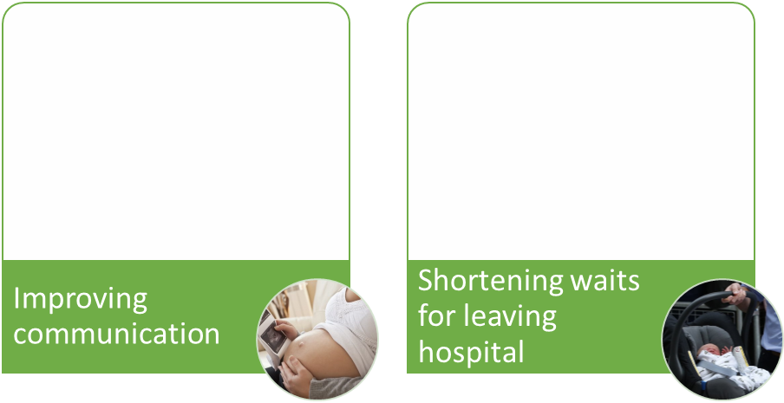

Trust is reviewing its maternity communication to help parents to better understand the services

Trust has reviewed its use of pharmacy for mothers to avoid them having to stay in hospital longer whilst waiting on over-the-counter painkillers

* We were pleased to hear about the pilot the Trust is running: non-invasive pulse oximetry testing on all babies born for early diagnosis of cardiac abnormalities or sepsis. This has already picked up at least two babies with cardiac issues, so the babies can get the early treatment they need. It is anticipated that the pilot will lead to a national screening test.

## Improving maternity services nationally

Local people have also contributed to the national maternity picture, through Healthwatch England including details in their [maternity briefing](http://www.healthwatch.co.uk/resource/we-respond-national-maternity-review) and in their [submission of evidence](http://www.healthwatch.co.uk/news/five-common-concerns-maternity-services) about the issues people have told local Healthwatch to the review of maternity service. The review recommendations 2 are now available

## What still needs to happen?

Many parents we spoke to have struggled accessing The Gattton’s (Burgess Hill). The Trust told us they had now got new leadership in this service and that of the community services. We were told the *“new team leader … will work with the community midwifery teams to ensure we are delivering safe, effective, efficient services as close to the women’s homes as possible where accommodation allows.* However, the location of midwifery services for parents in Hassocks was outside the Trust’s control.

We are currently working to influence the commissioners to look at this issue.

2 <https://www.england.nhs.uk/2016/02/maternity-review-2/>