Top tips for commissioners: Young people leading the commissioning of their health and social care services.

From 2014-2016, Healthwatch Bristol and Bristol, South Gloucestershire and North Somerset Clinical Commissioning Groups (CCGs) worked together to set up and facilitate a Young People’s Reference Group (YPRG) to feed into and help shape the commissioning process for Children’s Community Health Services (CCHS) in Bristol, South Gloucestershire and North Somerset. This ‘top tips’ document gives a brief summary of each stage of the process and some top tips for commissioners to consider when carrying out their own commissioning exercises.
W: http://bit.ly/2d2RhJx

Stage | Brief summary of how we did it | Top tips
Planning | Before any young people were recruited, Bristol CCG contacted Healthwatch Bristol and suggested they could work together to facilitate a YPRG.  More information about Healthwatch Bristol’s Young Healthwatch: http://healthwatchbristol.co.uk/about-us/young-healthwatch/ | Work with an organisation that has experience working with children and young people (CYP). They will have contacts with CYP (which will help with recruitment) and will also have the skills to make YPRG meeting accessible and enjoyable. Working with another organisation also means that CYP can be involved in other projects, outside of commissioning related work, which will keep them engaged during periods when there is little to do around the commissioning.  Consider, in detail, how young people will be involved in the commissioning process and how you as a commissioning organisation will ensure that the young people’s input is recognised and acted upon.  Remember these top tips at every stage of the commissioning process:  - the process should be education and enjoyable (for young people and commissioners!);  - always explain WHY you’re asking a question/ carrying out a particular stage of the process;  - evidence to young people how their input has been used in the process (eg. invite young people to meet the commissioners, include their work in official publications);  - commissioners should regularly attend YPRG meetings to hear from them directly;  - hold regular meetings throughout the whole process (no quiet times!) to keep young people engaged and interested. This can include providing opportunities not directly linked to the commissioning.
Involvement | The YPRG members started by designing a service pathway for Children’s Community Health Services (CCHS)  The pathway was used by the commissioners to develop the service specifications for the new CCHS.  W: http://bit.ly/2cZHUy8  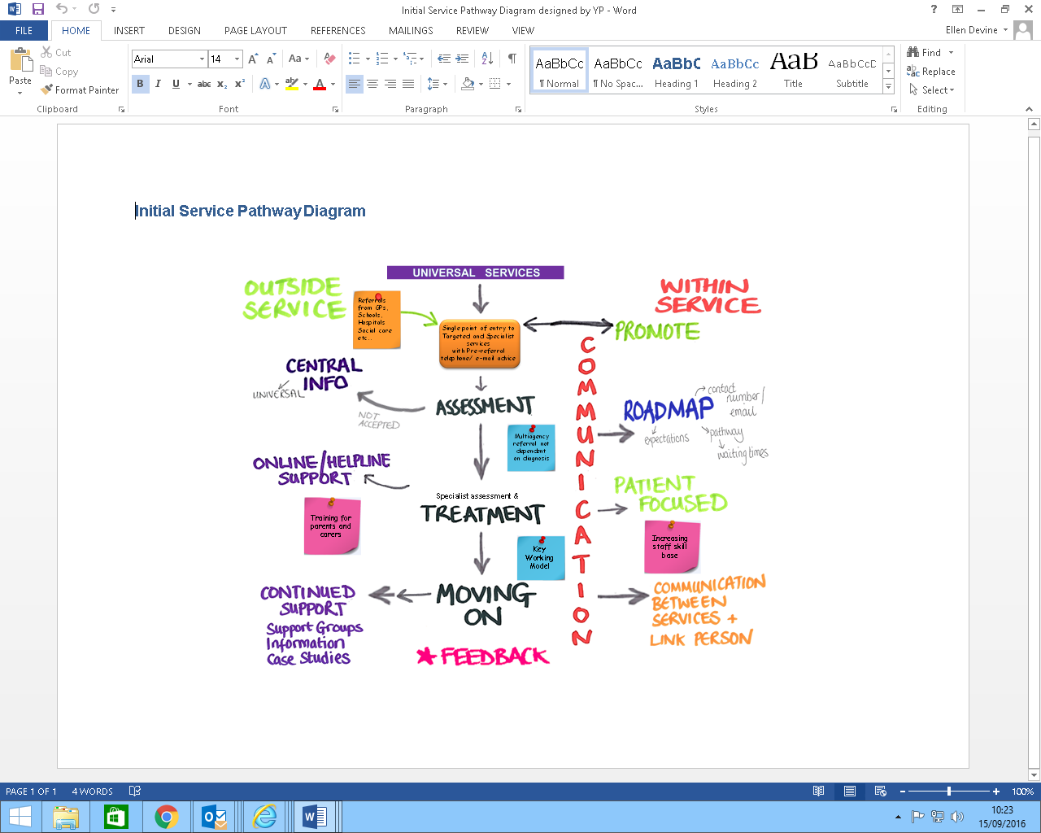 | Work with young people to make a plan for how they want to be involved in the commissioning process. Ask them about their experiences, interests, hopes for the future. See how the YPRG can help them.  Regardless of service, get YP to think about how it should feel to be a young person moving through the service (how do they feel beforehand, how do they find out about service, how to they get into service…..)  Be creative:  - sometimes it can be difficult to talk about your own experiences or feelings in front of a group of people; ask young people to look at case studies/ stories you’ve prepared about a young person using the service and imagine themselves or a friend in that situation.  - use art, splash diagrams, post-it notes, role play to get everyone involved in thinking about the questions.
Gathering feedback/ consultation | Giving feedback:  The YPRG discussed lots of the services included in the re-commissioning, including Children and Adolescent Mental Health Services (CAMHS), School Nurses, Occupational Therapy and Physiotherapy Services and many more!  Their feedback was included in the Involvement and the Engagement Reports produced by the commissioners and helped shape the ‘Draft Plan’ for the future CCHS.  Draft plan: http://bit.ly/2cO6ONY  Designing the consultation:  The next stage was to go out to consultation and get as much feedback on the plans for CCHS as possible. The YPRG helped design the consultation website, a promotional animation and postcards. They also stared on the Made in Bristol TV channel and promoted the consultation to children and young people in their schools and other community groups.  Consultation website (including animation): https://www.yourhealthyfuture.org/  Developing our skills as facilitators:  The YPRG members did Young Healthwatch training so that they developed the skills to support other children and young people to have their voices heard. During the training, the YPRG members helped set up a Young Healthwatch Twitter (@YHWbristol) account so we could spread the word about the consultation via social media.  Learning about commissioning:  The commissioners definitely knew who we were after we took over their offices for a day! We got to meet with lots of people working in a range of roles at Bristol Clinical Commissioning Group and quizzed them on everything from their work routine and how much they earn to their favourite subjects at school. We even got them to share their baby photos with us!  YPRG CCG Takeover day report: http://bit.ly/2cAMYoZ | General:  - Consultation needs to be wider than your YPRG (eg. with schools, other youth groups, parent groups, online).  - Upskill YPRG members to encourage other young people to give feedback.  - Coproduce with young people the consultation method/materials.  Ideas for co-producing consultation materials:  - work with young people to storyboard an animation or film (bring in a film maker to support with this), then ask young people to star in the film/ record their voices for the film;  - get young people involved in promoting the consultation via social media;  - provide opportunities for young people to support with website development;  - young people can design postcards/ posters/ flyers and help distribute them;  - if developing a pathway as part of the consultation, support young people to be involved in designing the pathway and then sense checking how it is explained in the consultation materials;  - this is a great stage to provide ‘meet the commissioner’ opportunities (our YPRG loved our CCG Takeover day).
Evaluation/ procurement | Once organisations had put in their bids, or applications, to provide CCHS, the YPRG attended training sessions to learn all about procurement. We then read the bids submitted and asked the candidates questions about their bids. We then all gave our individual and consensus scores. One of our members then took the YPRG consensus score to the commissioners.  YPRG evaluation meeting report: http://bit.ly/2cU2RXQ | Facilitated training on procurement and evaluating bids with the YPRG: youth workers and procurement staff should work together to create young people friendly procurement training. Consider including in the training:  - practice evaluations on topics young people are familiar and interested in (we used ‘buying a mobile phone’: we designed a service specification for what we wanted from a mobile phone; we asked YPRG members to each come up with their ‘bid’ for our custom; some of the young people had to come up with an inadequate bid (one young person offered us a typewriter) and others had to come up with excellent bids that evidenced what the outcomes of us having a particular phone would be)  Respect young people’s timetables (be aware of exam periods and summer holidays when young people may be unavailable).  During the evaluation of the bids:  - give plenty of time to read, understand and evaluate the bids;  - ask potential providers to answer a specific question which will be evaluated by the YPRG (at an earlier stage, you could involve YPRG in writing this question);  - present the bids to YP so they are accessible, for example, print them all on one sheet of paper, colour code different bids and read them aloud as a group;  - invite bidders to present to YPRG and allow the young people time to ask questions around the bid;  - ask a member of the procurement team to attend the training and the evaluation meeting;  - nominate a young person to attend the overall consensus meeting with other commissioners and present the YPRG consensus score.
Handing over to the new providers | This is what’s happening now (October 2016). The YPRG, with the support of Healthwatch Bristol and Bristol, South Gloucestershire and North Somerset Clinical Commissioning Groups will continue to ensure that the providers of CCHS involved children and young people in the development of all their services. | Inform the YPRG of the outcomes of the procurement and how their input contributed to the decision.  Have a clear plan for how YPRG will continue to be involved with the provider of the service (if this is possible).  Continue to communicate with YPRG (don’t go silent now the commissioning is over!)  Reward and recognise the young people involved in the process; for example via certificates, a celebration event, letters of recommendations, contact details for references.  If the YPRG is finishing, help young people find other youth groups they can be involved with.

For more information about involving children and young people in commissioning of health and social care services, see/contact:

Creating a Children and Young People friendly local Healthwatch (Healthwatch England Toolkit)
Available via the Healthwatch Hub: http://bit.ly/1svglPr
NCB publish new resources to help inform children and young people's participation in health
The National Children's Bureau have published, 'Children, Young people and Health Participation' and 'Ready to listen.' Both publications aim to support the involvement of children, young people and their families in local decisions about health.
W: http://bit.ly/22i0dgY
W: http://bit.ly/22i0oIY
W: http://generationr.org.uk/
Also see: Get Your Rights W: www.getyourrights.org
Engagement Collaborative
As part of & Us, the Royal College of Pediatrics and Child Health (RCPCH) has developed a unique role for professionals to join the College in improving child health. The College has developed a new Children and Young People's Engagement Collaborative.
W: http://bit.ly/22i1qoy
NHS England Youth Forum
W: https://www.england.nhs.uk/ourwork/patients/public-voice/yth-for/
E: alice.williams2@nhs.net

