Sunderland’s Young People and their Experiences of Healthcare Services

December 2015

Contents

“I’ve got nothing to complain about.
I think the NHS is amazing”

“A negative is waiting times if you have an appointment at a certain time and you are waiting ages and you’re in pain”

“All staff have always been friendly and done their best to give a swift service”

“Sometimes doctors were understanding and dealt with me with respect. Others did not seem to care and wanted me out as soon as possible”

“I had a positive experience…they all
helped me in different ways”

“My family have accessed Sunderland healthcare and are happy with the services as they were seen as quickly as possible with a high standards of care”.

Young People in Sunderland

Introducing the Research

Healthwatch Sunderland is a local, independent consumer champion whose aim is to strengthen the collective voice of people and communities in influencing local health and social care services to better meet their needs. It supports people and groups to find the right health and social care services by providing information, advice and signposting. It also encourages people to share their views and experiences of services.

Healthwatch Sunderland commissioned Groundwork North East to engage with young people across the city and establish their views and needs around health and social care. In order to process the large volume of data that has been collected, Groundwork has been working in partnership with Eljay Research, a consultancy based in Durham.

The aims of this research study were to:

- Encourage young people across Sunderland to participate in the Healthwatch Survey, maximising their involvement using several good practice techniques.

- Work with the Groundwork Youth Team and young people taking part in our National Citizenship Service programme in Sunderland to gather data and build relationships with young people across the city

- Confidentially gather, collate and thoroughly analyse robust data to fully understand in detail young people’s healthcare experiences, attitudes and needs.

- Produce a report presenting the findings and highlighting key messages of the research.

The Research Methodology

204 young people participated in the project over the summer of 2015. Groundwork developed the ‘Young People’s Survey’ which was approved by Healthwatch before youth engagement commenced.

During the research period, Groundwork staff delivered workshops and focus groups around health and social care issues to a range of young people’s groups. Part of these sessions required young people to complete the aforementioned survey. Acknowledgements are extended to the following groups for their valuable participation in the research:

- National Citizenship Service (NCS)
- Box Youth Project
- Houghton Kepier Group
- Lambton Street Youth Group
- Red House Academy Youth Group
- Young Asian Voices
- Miscellaneous outreach meetings and sessions

*The feedback from the research showed no indication of race or gender issues amongst young people.

How the Survey Data is presented

Findings of the Young People’s Survey are presented throughout this report. Charts show a number of findings graphically to illustrate key findings and themes.

To facilitate meaningful comparisons over time, the data is presented using statistics, accompanied by actual quotes – with young people quoted verbatim, but anonymously, to preserve confidentiality.

Please note that percentages have been rounded to the nearest whole number, and may therefore not total exactly 100. The number of respondents to each question is indicated by ‘n=x’, where x is the total.

5 Key Messages

1. The Value of the Information Collected.

In considering the findings of the research, it is useful to initially examine the validity of the data obtained, with three key factors. Firstly, the findings are current and focused. The data obtained is both fresh and new, harnessing the most up to date information available from more than 200 young people in Sunderland – many of whom have both first-hand and family/friend healthcare experiences on which to base their views. Secondly, it is a small but representative sample, ensuring the views of those of both genders, young people aged 11-25 and with residence across the area are well-represented. Thirdly, it is impartial. The data was collated, analysed and presented by persons working for, but NOT employed within the framework of Healthwatch, maintaining a professional independence necessary for the execution of the research.

2. Young People Have, on Average, Accessed Four Healthcare Services in Sunderland.

These services are heavily dominated by experiences of doctors and dentists. However, almost three-quarters of the young people surveyed had accessed a walk in centre, whilst two-thirds had been to an optician, and over 40% had used an emergency healthcare service. So what do the findings of the research tell us? The answer is found in a number of key and clear messages.

3. Two Out of Every Three Young People Have a Positive Experience of Healthcare Services in Sunderland.

Theirs is an experience which is based on encountering healthcare professionals who are viewed as supportive, understanding, helpful, informative and kind – delivering timely and successful treatment.

4. However, Excessive Waiting Times Dominate Negative Experiences.

Where young people are less than happy with the service they have received, this is heavily and fundamentally as a result of what are considered to be excessive waiting times. Young people sometimes detail difficulties in accessing healthcare appointments, accompanied by delays of ‘hours’ in waiting to be seen once on-site. This is clearly a source of irritation and disappointment for many, and is the number one improvement requested – by far.

5. Yet a Majority of Young People Find Healthcare Access in Sunderland to be an Easy Process.

Despite the aforementioned problems, healthcare is, in general, found to be accessible and - leaving aside waiting times - unlikely to present any further, significant barriers.

Healthcare Services Accessed in Sunderland

Figure 1 shows all healthcare services accessed by the young people in this study. This spotlights high usage of doctor and dentist services – each used by over 90% of young people, with accompanying high levels of usage of walk in centres (74%), opticians (64%) and emergency services (41%).

Figure 1

n=192

*Other healthcare services included orthodontists, physiotherapy, occupational therapy and counselling.

More than one service had frequently been used by young people, with an average experience of FOUR services.

Positive and Negative Experiences of Healthcare Services

Around two-thirds (66%) of the young people who participated in the research reported positive experiences of healthcare in Sunderland. However, for around 1 in every 5 young people (19%) their experiences were negative, with a further 14% detailing a mixed experience (See figure 2).

Figure 2

n=185

What Underpins Positive and Negative Healthcare Experiences?

Underpinning positive experiences of healthcare were a raft of descriptions of highly regarded healthcare professionals, providing informative advice, and timely and successful treatment. In contrast, where a negative experience was in evidence this was – by far – as a result of what were felt to be excessive waiting times. (See figure 3).

Figure 3
Positives and Negatives

The following comments reflect a genuine appreciation by young people of the healthcare professionals they have had experience of, with a real focus on the personable qualities of these professionals:

“the doctors are very supportive and are always there to help”

“the staff were kind and welcoming”

“it was a positive experience because the nurses provided everything that I needed”

“me and my boyfriend got advice about contraception and now I’m taking the pill which is good as we are not ready to have kids now and we wouldn't be able to look after them properly”

“the doctors and nurses were kind and understanding”

“all staff have always been friendly and done their best to give a swift service”

“they were all very helpful and polite to me”

“every doctor made me feel comfortable”

“they gave me all the help, information and support that I needed”.

In contrast, was a clearly negative focus on long waiting times:

“we had to wait for hours to be seen about an allergic reaction”

“it’s a very good service but waiting hours to be seen to can be annoying”

“in A & E we had to wait all night to be seen to!”

“I got better but I waited hours to get seen to”

“doctors’ receptionists are very rude and not really bothered it you get an appointment or not. At the Walk in centre there is a long wait but at least they see you”

“they take you in hospital and leave you with staff and those staff take ages”

“the last time when I wanted to see a doctor I needed to wait for two weeks till I could get booked in!”

The Experiences of Friends and Family Accessing Healthcare in Sunderland

60% of the young people surveyed detailed experiences of Sunderland healthcare by family and friends. Of those who felt able to comment about the quality of the experience, 63% described this in positive terms, with the remainder (37%) describing negative or mixed experiences. (See figure 4).

Figure 4

n=116

Both positive and negative experiences are reflected in the following comments:

“my brother went in an ambulance… the care he got was great”

“My mam and me received tablets we needed almost immediately after we asked. However, it took months for my friend to get an appointment at the doctors”

“my brother experienced stomach pain and he waited for three hours to be seen then another two hours for treatment”

“my Grandad was on the dementia ward…the people were lovely and always at hand”

“my mum has a thyroid problem so she always has to get checked at the doctors. She always has a positive experience”.

“my mother was unhappy with the services as the recommendations she got were incorrect and ill-advised”.

The Ease of Accessing Healthcare in Sunderland

As shown in figure 5, despite some experiences of what are considered to be excessive waiting times, around three-quarters (74%) of the young people surveyed found accessing healthcare in Sunderland to be an easy process.

Figure 5
n=189

Barriers to Accessing Healthcare in Sunderland

In the context of aforementioned concerns, waiting times emerge as the number one barrier to accessing healthcare services in Sunderland by a majority (85%) of young people. (See figure 6). More than one barrier was sometimes identified.

Figure 6

n=192

*Other barriers included fear, embarrassment, uncertainty of locations, and transport issues.

Requested Service Improvements

Around two-thirds (67%) of the young people surveyed suggested service improvements. Such improvements were heavily dominated by a need for increased speed in being seen/reduced waiting times – with approaching half (47%) of all the young people surveyed requesting a quicker service. Other improvements – each in contrast requested by fewer than 5% of young people, included improved service accessibility, reduced costs, increased information, additional medical resources, treatment prioritisation and enhanced support and professional understanding. (See figure 7).

Figure 7
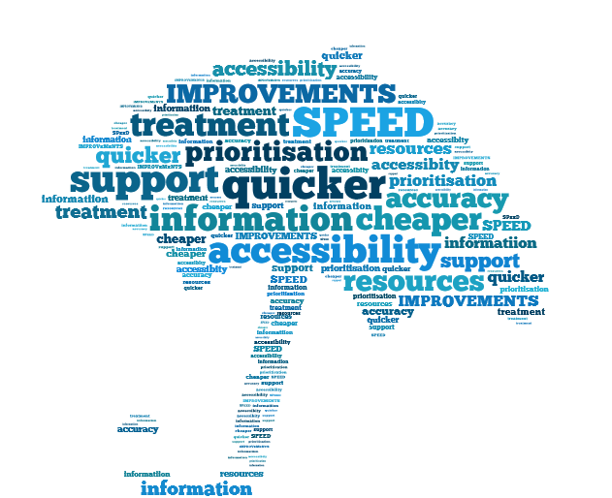
n=129

Young people commented:

“waiting lists for the NHS should be improved…I had to wait three to four months for an HRI scan”

“they could have given me a bit more support up until I got the help I needed as three months is too long a wait”

“it could have been quicker in A and E”

“you should not have to book appointments at the walk in centre …what’s the point of it being called a walk in centre?”

“waiting times should be shorter”

“there should be more information provided on mental health services”.

Next steps

As per the brief agreed, the next phase of the project will aim to achieve the following:

- Contact NCS graduates following their participation in the survey in the summer and encourage them to volunteer with Healthwatch in the longer term.

- Establish a ‘Young people’s health Board’ – this will allow young people to really develop their own voice about health and social care issues in Sunderland.

- Finalise the project report

- Handover to Healthwatch in January 2016.

